# Project Title – Entertainer Data Analysis Domain – Film and Entertainment Author – VATSALA BHATT

**Index**

|  |  |  |
| --- | --- | --- |
| **Sl. No.** | **Title** | **Page no.** |
| 1 | Abstract | 3 |
| 2 | Given Tasks | 3 |
| 3 | Scope | 3 |
| 4 | Architecture Design | 4 |
| 5 | Data Preparation | 6 |
| 6 | Connect Data with Power BI Desktop | 10 |

## Abstract –

Normal life can be stressful, and people need to relax. Being entertained by others is a wonderful way to take some time out of life. It Can reduce stress and make life’s issues easier to face. The media and entertainment industry consists of film, television, radio and print. These segments include movies, TC shows, radio shows, news, music, newspaper, magazines, and books.

Entertainment industry is a group of sub-industries devoted to entertainment. Entertainment industry is used to describe the mass media companies that control the distribution and manufacture of mass media entertainment.

## Given Tasks –

* Task #1 - In a word document write the process and data added to the current dataset.
* Task #2 – You can add your data as per your convenience.
* Task #3 - Do the data preparation part.
* Task #4 – Build the dashboards.
* Task #5 – Build a Storyline.

## Scope –

* The main Theme of my dashboards is number of awards won by entertainers throughout their life-time. I have created 2 dashboards showing their award-winning performances. Dashboards show highest number of nominees, Oscar, Emmy, Grammy and other awards Won. So, we can analyze which entertainer is the best according to the data provided.
* My main theme is to create 2 dashboards: Dashboard 1 – shows Top 10 all-time entertainer’s along with total nominees and Dashboard 2 – Gives insights about the mega Awards won by the top 10 entertainers,
* Who got the success at young age and the IMDB rating for the top 5 movies.

# Architecture Design

* + The Architecture Design of the entire project is shown below





**Power Bi Desktop, Client, Visualization, Dashboards.**

* The Entire data source is our excel file. This excel file is connected to the Power Bi Desktop from which data can be accessed and processed.
* Power Bi Desktop has various architectural components which can help us to analyze the data and create dashboards and reports.
* Screen of Power Bi Desktop, and various charts and dashboards are present at the client side from Power Bi Service.
* One can use Power Query Editor to process, Clean the Data and then use the Data to create informative Dashboards and reports.
* If client is not satisfied with the result, he/she has to select data accordingly otherwise make required changes to show the expected result.

## Data Preparation –

* Data was provided into three parts in excel format which were Entertainer - Basic Info, Entertainer – Breakthrough Info and Entertainer

– Last work Info.

* Basic Info includes name, gender and birth year of entertainer.
* Breakthrough Info includes year of breakthrough/#1 hit/award nomination, breakthrough name, year of first Oscar/Grammy/Emmy along with name of entertainers.
* Last work Info includes last major work (arguable), year of death (if they are) along with name of entertainers.
* Basic Info Excel sheet:

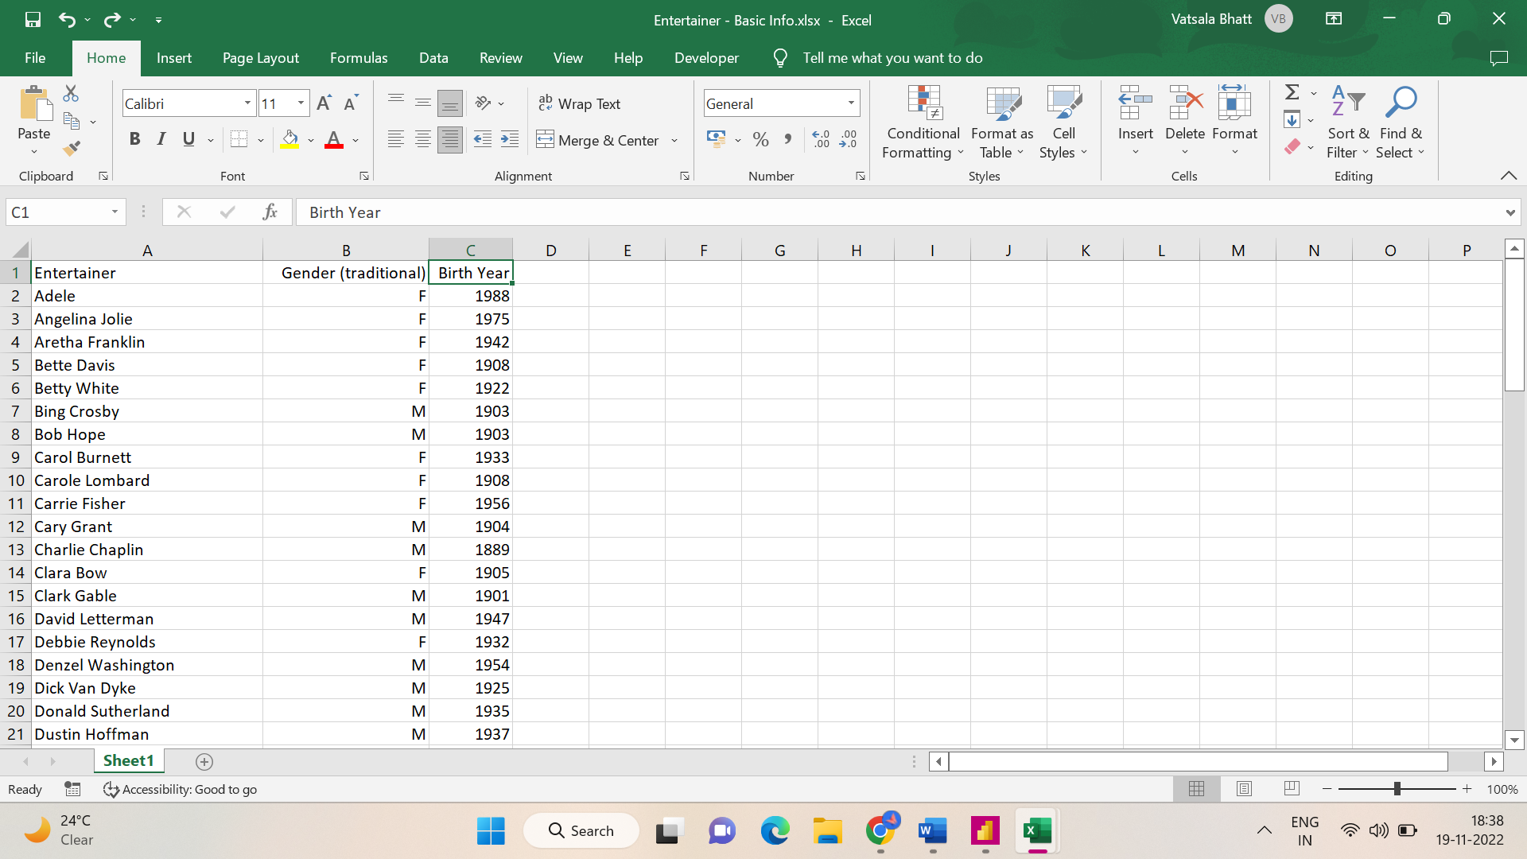

* Breakthrough Info Excel sheet:

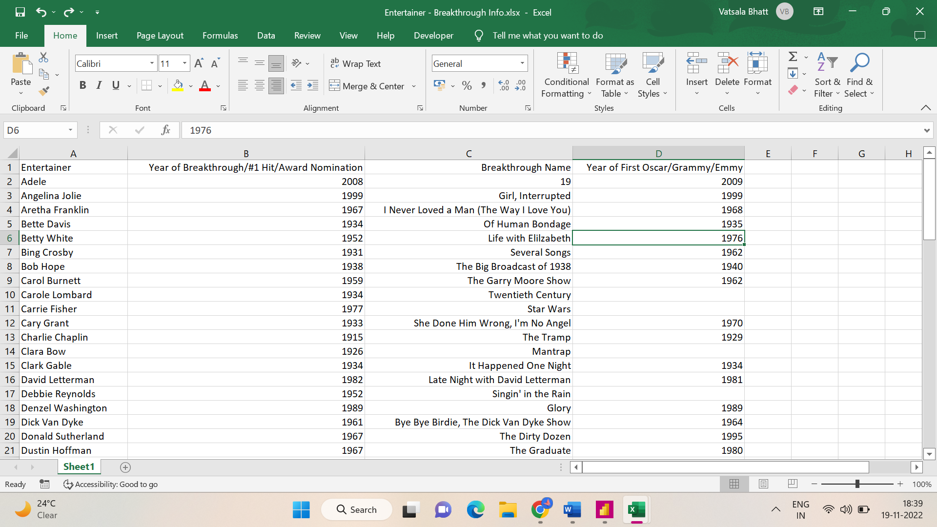

* Last work Info Excel sheet:

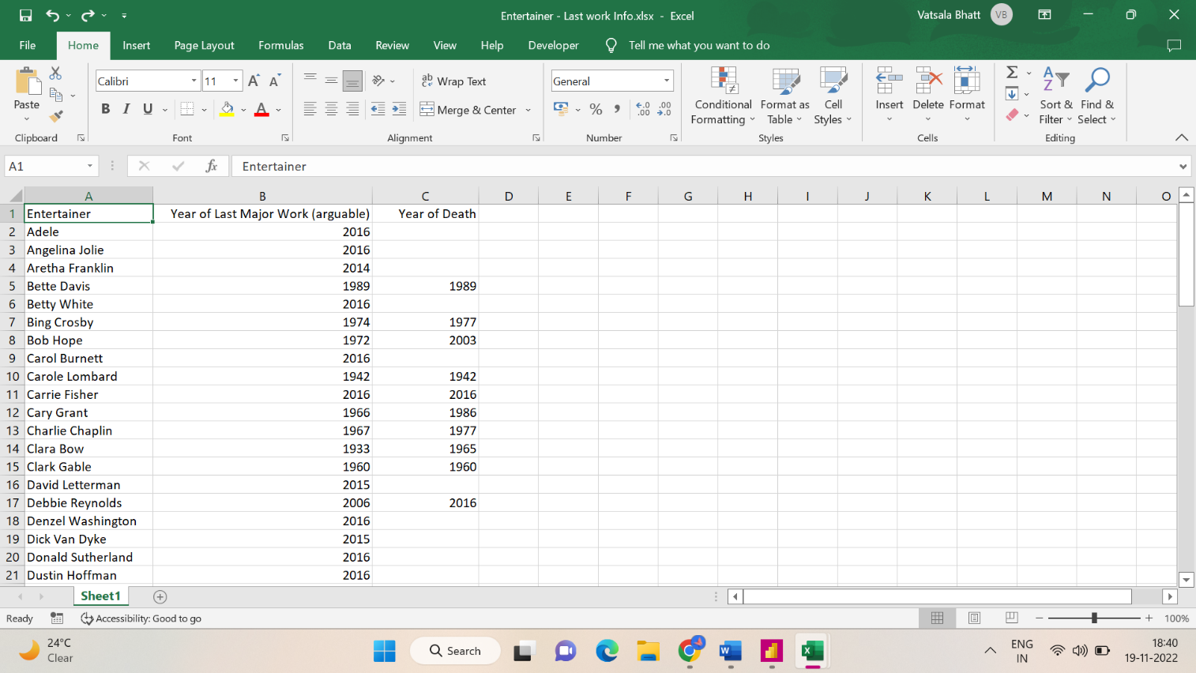

* As the data was in three different excel sheet, I combined them into one single sheet namely Entertainer Final sheet. As the data was not enough sufficient to do analysis, I added some external information like awards they won, nominees etc. through different online sources like IMDb.
* Processed data –

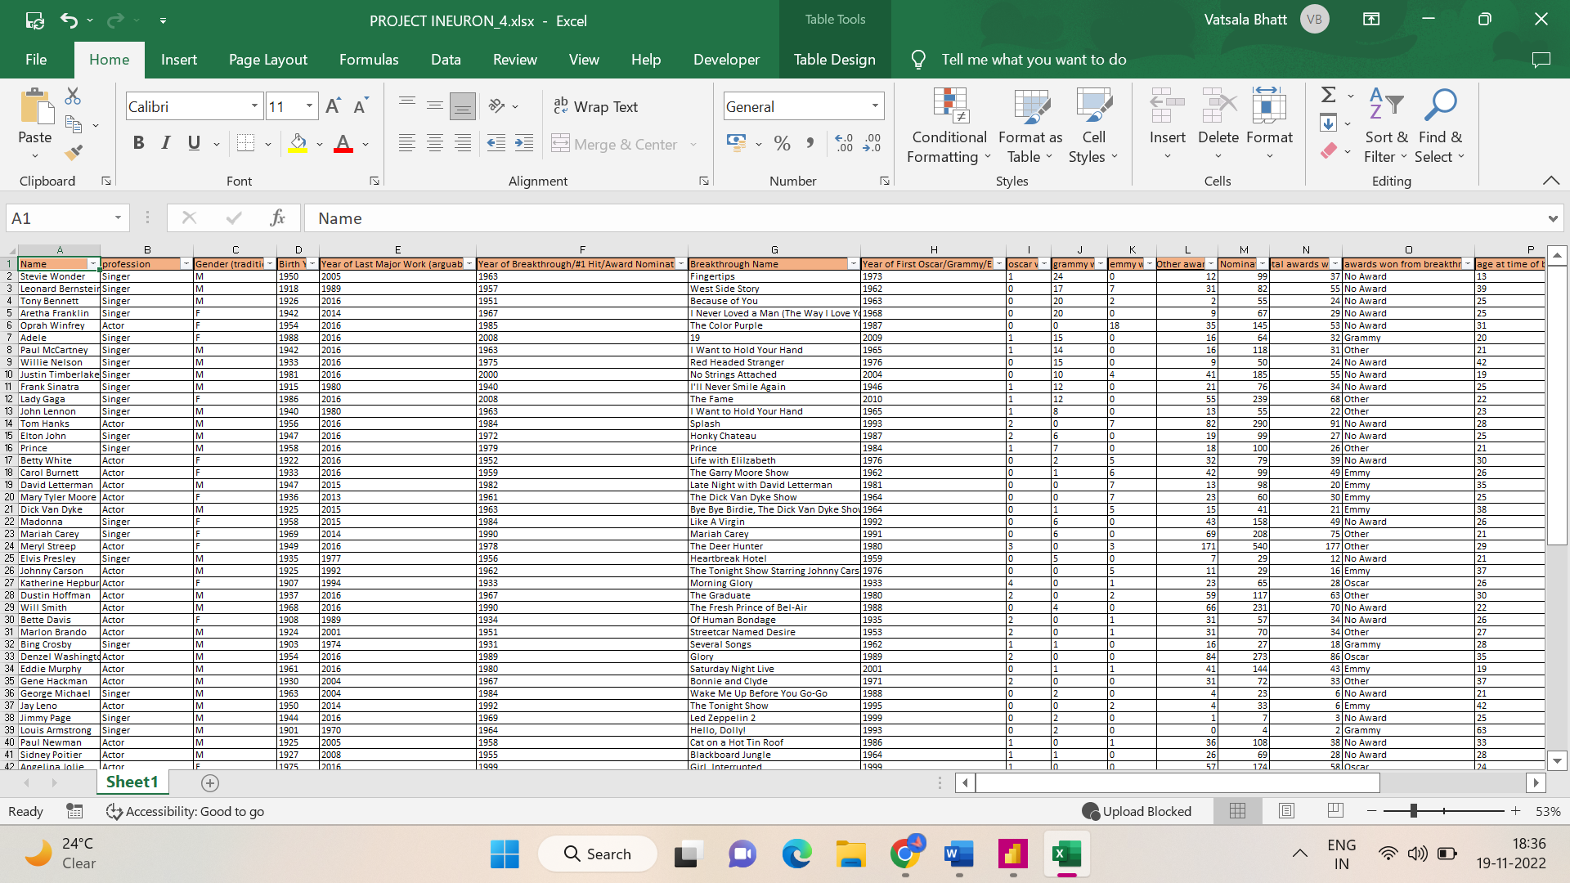

## Columns Names –

* Name– Name of the Entertainer
* Profession – Singer/Actor
* Gender – Gender of the Entertainer
* Birth year – Birth Year of the Entertainer
* Year of Breakthrough/#1 hit/ Award Nomination
* Breakthrough Name – Name of the breakthrough (Movie/Tv show/ album).
* Year of first Oscar/Grammy/Emmy
* Year of last major work
* Award won from breakthrough
* Total Awards won
* Total Nominees
* Oscar won – Total number of Oscars won
* Grammy Won – Total number of Grammy won
* Emmy Won – Total number of Emmy won
* Other awards = Total number of other awards apart from Oscar, Grammy, Emmy.
* Age at the time of breakthrough
* Breakthrough movies IMDB ratings

## Importing Data in Power Bi Desktop for Creating Dashboards –

* After Downloading and installing Power Bi Desktop on your system, open the Power Bi Desktop.
* User-interface of Power Bi Desktop

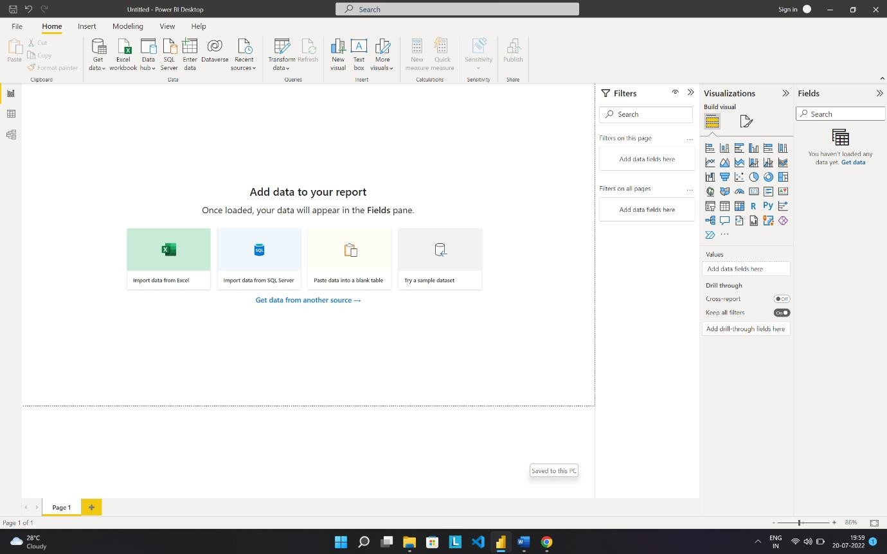

* You can import your data by clicking on Get Data. You’ll get option to

import the data.

* This is where you can make amazing dashboards and reports.